

**The Storage IT Industry Ecosystem**

**A White Paper**

**By, Tariq Nazeer**

Ecosystem Development

Intelligent Storage & Computing Lab

**Issue:**

**Date:**

To be removed for release

|  |  |
| --- | --- |
| V 1.0 | 2/09/24 initial draft |
|  |  |





|  |
| --- |
| **Copyright © 2023, Futurewei®® Technologies, Inc. All rights reserved.**  No part of this document may be reproduced or transmitted in any form or by any means without prior written consent of Futurewei® Technologies.  A picture containing object  Description automatically generated**Trademarks and Permissions**  and other Futurewei® trademarks are trademarks of Futurewei® Technologies. Huawei trademarks are trademarks of Huawei Technologies Co., Ltd. All other trademarks and trade names mentioned in this document are the property of their respective holders.  **Notice**  The purchased products, services, and features are stipulated by the contract made between Huawei and the customer. All or part of the products, services, and features described in this document may not be within the purchase scope or the usage scope. Unless otherwise specified in the contract, all statements, information, and recommendations in this document are provided "AS IS" without warranties, guarantees, or representations of any kind, either express or implied.  The information in this document is subject to change without notice. Every effort has been made in the preparation of this document to ensure accuracy of the contents, but all statements, information, and recommendations in this document do not constitute a warranty of any kind, express or implied. |

|  |  |
| --- | --- |
|  | |
| Futurewei® Technologies, Inc.  Boston Research Center | |
| Address: | 111 Speen Street, Suite 114  Framingham, MA 01701  United States of America |
| Website: | <http://www.futurewei.com/> |

Contents

1. Introduction 5

2. The Information Technology (IT) Ecosystem 6

2.1 Why does it matter? 6

2.2 Partner-types that make up an IT Ecosystem 6

2.2.1 Technology (Build) Partners 7

2.2.2 Services Partners 7

2.2.3 Channel (Sell) Partners 8

3. Storage IT Ecosystem Building 8

3.1 Market Centric Approach 9

3.2 Customer Centric Approach 9

4. Storage Architecture Layer Categories 10

4.1 Storage & Connectivity Hardware Layer 11

4.1.1 External Storage Hardware Top Vendors 11

4.1.2 Storage Networking Connectivity Top Vendors 12

4.2 Storage Software Layer 14

4.2.1 Data Protection & Backup Top Vendors 15

4.2.2 Data Migration, Integration and Mobility Top Vendors 16

4.3 Infrastructure Layer 17

4.3.1 Container Management and Orchestration Top Vendors 18

4.3.2 Hyper Converged Infrastructure (HCI) Top Vendors 19

4.3.3 Network Performance Management Top Vendors 20

4.4 Data Layer 21

4.4.1 Data Lifecycle Management/Data Archiving Top Vendors 22

4.4.2 Storage Analytics & Monitoring Top Vendors 23

4.5 Security Layer 24

4.5.1 Endpoint Protection Top Vendors 25

4.5.2 Identify & Access Management (IAM) Top Vendors 26

4.6 Ecosystem Partnership summary with Storage Hardware Vendors 27

5. Customer Spending on Storage Technology 28

6. Primary Storage Vendors’ Partner Program & Ecosystems 30

6.1 Dell Partner Program ® 31

6.1.1 Dell ® Ecosystem Profile 32

6.1.2 Dell® Technologies Extended Industry Partnerships 33

6.2 Huawei® Partner Program 33

6.2.1 Huawei® Ecosystem Profile 36

6.3 NetApp® Partner Program 36

6.3.1 NetApp® Ecosystem Profile 37

6.4 Hewlett-Packard Enterprise ® (HPE) Partner Program 38

6.4.1 HPE Ecosystem Profile 38

6.5 Pure Storage ® Partner Program 40

6.5.1 Pure Storage ® Ecosystem Profile 41

6.6 Hitachi® Partner Program 42

6.6.1 Hitachi® Ecosystem Profile 43

6.7 IBM® Partner Program 44

6.7.1 IBM® Ecosystem Profile 45

6.8 Lenovo ® Partner Program 45

6.8.1 Lenovo ® Ecosystem Profile 46

7. Storage Vendor Ecosystem Comparison & Learnings 47

7.1 Ecosystem Partner Targeting 48

7.2 Best Practice: Pure Storage ® IT Ecosystem 48

8. Conclusion & Recommendations 49

9. References 51

# Introduction

IT Ecosystems are a critical requirement for vendor success, in today’s IT industry. They are more than just old-fashioned partner programs, or even strategic alliance programs. The proliferation of IT Ecosystems is a direct result of the industry’s attempt to keep up with the ever-evolving needs of a dynamic customer base, who is demanding more functionality and capability, much faster and at a lower cost than ever before. IT Ecosystems have as a result sprung up, where vendors who once delivered total solutions directly to their customers, now partner with a wide ecosystem of “build”, “service” and “sell” partners to meet these market demands.

The focus of this white paper is on the IT Ecosystem for the Data Storage Industry. It will explore what an IT ecosystem is, why they matter and provide an overview of the types of partners that make up a comprehensive ecosystem. Ecosystem requirements will be analyzed through both a “market-centric” and “customer-centric” approach, to help outline what it would take to build a world-class IT ecosystem that will drive customer success.

The paper introduces the technology categories making up a Data Storage ecosystem via a 5-layer architecture block diagram, identifying the key storage technology categories in each layer and the top vendors per category. The key storage categories in each layer are captured through guidance from IDC®’s Worldwide Software Taxonomy & Tracker report, and the top vendors per category is picked out by sifting through publicly published (and sometimes dated) Gartner ® Magic Quadrant reports for a market-centric view, and G2-Grid ® customer satisfaction reports for customer-centric prioritization. This was further strengthened with field data and customer escalations prioritizing solution gaps that were in demand. This approach helped identify the top storage vendors and their products for each IT technology architecture layer and category for the proposed best-in-class Storage IT ecosystem.

Customer spending on storage technology (poll data), was next looked at to identify the key storage use cases and technologies that customers were consuming storage for. This helped further prioritize storage solution areas, vendors, and products needed.

The whitepaper next moves on to study the industry’s top 8 global Storage Hardware Vendors and their Partner Programs, looking at their program structure, partnership tiers and partner benefits by tier, for each of the vendors. The Storage Hardware vendor ecosystem portals were also individually reviewed to identify the number of partners, partner types and categories in each respective vendor ecosystem. This was to identify current industry best practices.

The whitepaper concludes with a summary of key findings and a recommendation for the targeting of priority solutions and vendors for a foundational Storage IT Ecosystem for organizational success.

The entirety of this white paper is sourced by information published publicly. Any Information that is viewed as either confidential or restricted (e.g.: accessed from behind a firewall) is not privy to this research and therefore not included here in.

# The Information Technology (IT) Ecosystem

An ecosystem by its definition conveys a sense of inter-dependence and balance for each to survive and flourish. An IT Ecosystem, similarly, is an interdependency between a collaborative network of organizations, vendors, and service providers, who work together to produce, influence, service and sell - robust, scalable, and efficient end-to-end technology infrastructure solutions and services to customers.

## 2.1 Why does it matter?

The IT customer-consumer of today is more demanding than ever before and is looking for the latest best in class technology, cheaper and faster with features than go well beyond your traditional product or service. Therefore, speed of innovation, ever accelerating solution expectations and competitive pricing are basic table stakes for the customer’s own survival. While an IT provider may want to do it all — independently design, deploy, manage and service complete IT solutions — it's simply not realistic. These new buyers surround themselves with upwards of [seven different IT partners](https://www.canalys.com/insights/Have-the-industry-s-channel-chiefs-really-moved-to-an-ecosystem-model) © in a customer journey that now never ends. While solutions may be created in a way that's transparent to the customer, it takes a rich partner ecosystem to deliver and activate it.

## 2.2 Partner-types that make up an IT Ecosystem

An IT Ecosystem is made up of various partner types as seen in fig. 1 below. Partners are increasingly less defined by traditional partner types anymore (partner type boundaries have since blurred) but for the purpose of defining the IT ecosystem, this paper identifies the following 3 broad partner tracks for further understanding.

1. Technology Partners (Build)
2. Services Partners (Service)
3. Channel Partners (Sell)

#### Fig. 1: Ecosystem Partner Types

### 2.2.1 Technology (Build) Partners

Technology partners are primarily product builders - and are comprised of Independent Software Vendors (ISV’s), Independent Hardware Vendors (IHV’s) and Original Equipment Manufacturers (OEM’s). While an ISV’s focus is to build and bring to market software applications, IHVs design and manufacture hardware components independently. OEM’s similarly are companies that assemble and sell finished products using components from various suppliers, including IHVs.

### 2.2.2 Services Partners

Services IT Partners are companies that provide various IT-related services to support the technology needs of their clients. These services can encompass a wide range of offerings aimed at helping businesses plan, implement, manage, and optimize their IT infrastructure and systems.

They are comprised of Systems Integrators (SIs) who design, implement, and manage complex IT environments by bringing together various hardware, software, networking, and communication technologies into a unified environment, to Solution Providers (SPs) who offer end-to-end client solutions that go beyond individual products, addressing broader business challenges with a consultative and value-added approach.

Cloud Service Provider (CSPs) and Managed Service Provider (MSPs) are also important players in the Services Partners space. CSPs focus on delivering cloud-based infrastructure and services, while MSPs specialize in managing and supporting a wide range of IT services, often including infrastructure, applications, and end-user support. Some MSPs may also leverage the services of CSPs as part of their overall solution, especially in the context of delivering cloud-managed services.

The IT Services Partner list is long - from Consulting Partners to Academic, Research and Training Partners. And many Services Partners like SIs and SPs are also Technology Partners, who build their own products that go into their services.

### 2.2.3 Channel (Sell) Partners

Channel Partners, regularly also called Business Partners, are organizations that collaborate with either a Technology Partner or Services Partner to sell, distribute or transact products and services to and with end customers.

They are primarily made up of Reseller partners who purchase product from Technology Partners or Distributors and sell them directly to end customers. Value Added Reseller partners (VARs) not only sell products, but also add value to the product by including services such as customization, integration, and ongoing support for the customer.

Distributor partners act as intermediaries, between Technology Partners and Resellers.

It is clear from the 3 tracks above, that Partner types are indeed blurring with significant overlap between them. Many of the industry’s leader IT Ecosystem Programs still follow partner segmentation based on the Simple build (Technology), service (Service) and Channel (Sell) model and provide crossing between partner tracks as appropriate.

# Storage IT Ecosystem Building

Driven by skyrocketing volumes of digital data and the resulting need to access, analyze, manage, protect, and store this data, Storage IT Ecosystems have taken on a role of critical importance in the industry. Data is the new gold, and Storage is where that gold is stored.

When studying requirements for a comprehensive Storage IT Ecosystem, this paper approaches ecosystem building through two distinct approaches as illustrated in fig.2 below.

1. Market Centric Approach
2. Customer Centric Approach

**Market Centric**

**Customer Centric**

#### Fig. 2: Ecosystem Partner Types

## 3.1 Market Centric Approach

The Market Centric approach evaluates Ecosystem needs from the view of the external market. Reviewing industry market intelligence and data (% shares, CAGR growth rates, historical $ performance etc.). The approach also studies various analyst reports, looking through expert analyst predictions and forecasts (including IDC ® Storage Tracker and MarketScape ® Reporting, Forrester ® Reports and Gartner ® Magic Quadrant Matrixes, as publicly available).

## 3.2 Customer Centric Approach

This paper also studies the Storage IT Ecosystem requirements from the angle of the customer. Considering Storage Customer Survey Data, G2 ® Grid Customer Scoring Data, Field customer feedback (e.g.: user escalations) from current installed base etc. Furthermore, externally published storage vendor ecosystem intelligence is gathered (both from vendor partner programs and vendor’s ecosystem partners) to have a very detailed bottoms-up view of Ecosystem needs.

Together, the Market and Customer-centric approaches help provide a holistic method to evaluating Storage IT Ecosystem requirements for a state-of-the art Storage IT Ecosystem program.

# Storage Architecture Layer Categories

A storage IT ecosystem architecture is comprised of multiple layers with various technology categories that tie-in to storage hardware as indicated in Fig 3 below. If the block diagram is extended further upwards, you would expect to see a Business Layer and a User Layer on top of that, to complete the diagram. For this paper however, the focus is on layers and components that more directly relate to a storage IT ecosystem only as seen below.

#### Fig. 3: Ecosystem Technology Categories



The white paper will next list out each primary layer (above) of the Storage Ecosystem and describe its components, why it’s needed, and the market position for key vendors in the category. Where publicly available, the paper will also document market share data from trusted sources (e.g.: IDC ®) and provide analyst guidance on top market leaders (e.g.: Gartner ® Magic Quadrants) and customer preference data (e.g.: G2 ® scoring quadrants) for the key vendors.

## 4.1 Storage & Connectivity Hardware Layer

This layer comprises what is traditionally considered Storage Hardware and Networking. Storage systems (Traditional arrays, SAN, NAS, Object), Flash systems (All Flash, Hybrid Flash arrays, File Systems (Distributed File Systems, Network File Systems, Clustered and CIFS), and Storage Networking (Adaptors, Switches, Networking Protocols) are all key categories in this layer.

### 4.1.1 External Storage Hardware Top Vendors

The dominant external storage vendors show up in Gartner’s ® Leader quadrant (Fig 4) below. Dell Technologies ®, Huawei ®Storage, NetApp ®, Hewlett-Packard Enterprise ® (HPE), Pure Storage ®, Hitachi ®, IBM ® & Lenovo ® Storage are the world’s top 8 external storage vendors.

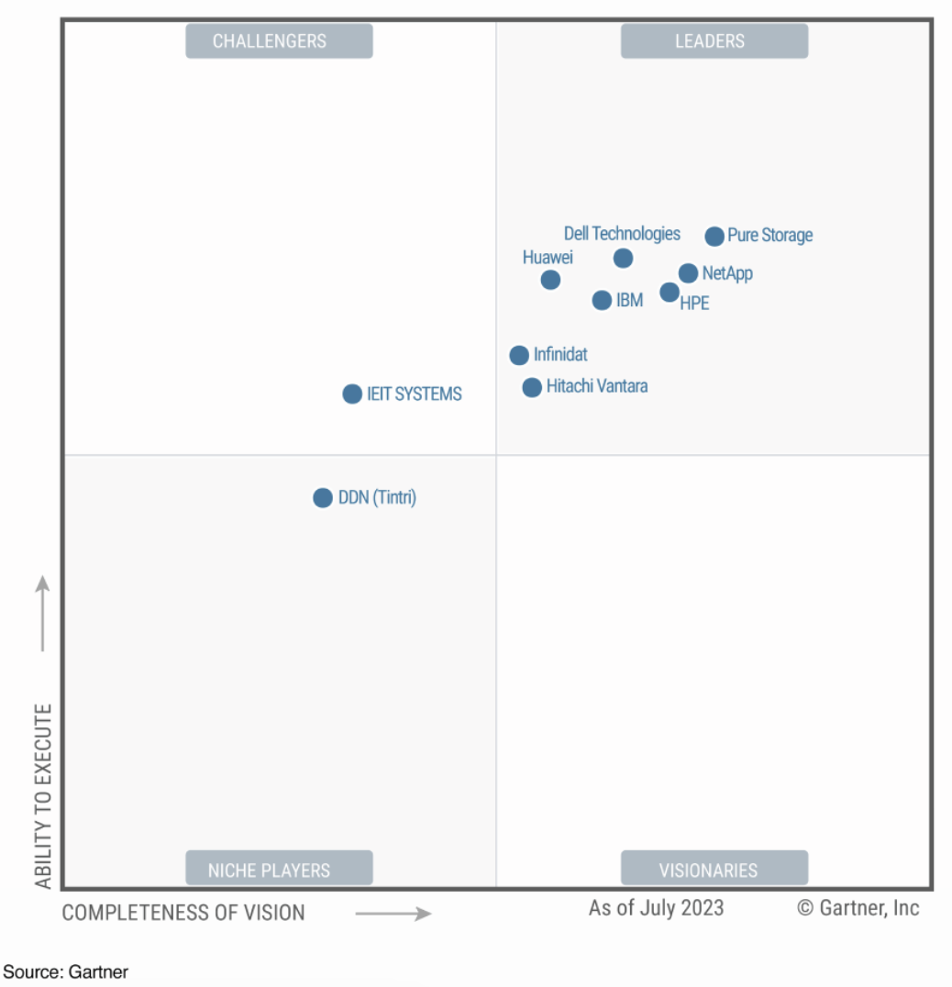

#### Fig. 4: Gartner ® Magic Quadrant for Primary Storage

The Storage hardware vendors 2022 market share numbers by IDC © are listed (Fig 4.1) below.

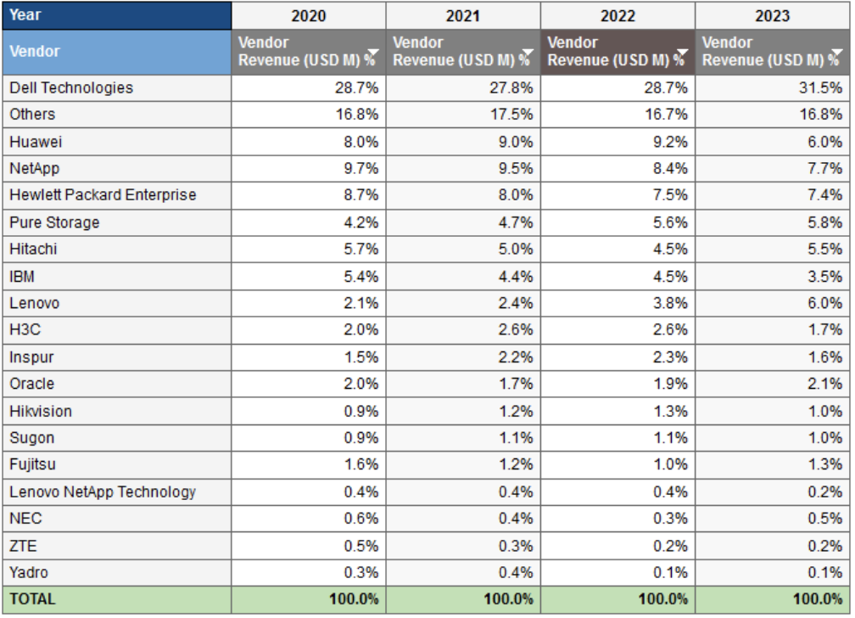

#### Fig. 4.1: Primary WW External Storage Tracker (IDC ®, 2023)

### 4.1.2 Storage Networking Connectivity Top Vendors

Storage Networking Connectivity serves as the backbone of storage networks, enabling efficient communication between servers and storage devices. The table below summarizes the primary purpose served by each network connectivity component.



The primary Networking and Connectivity Vendors in this space are listed in the table below.



## 4.2 Storage Software Layer

The Storage Software layer is a critical part of a Storage IT Ecosystem. This is because this layer closely integrated to the storage hardware below. The key categories that we will explore in this layer are:

* Data Protection & Backup software (Backup Software, Disaster Recovery Solutions, Snapshot & Replications tools, Continuous Data Protections CDP),
* Data Migration and Mobility software (Storage Migration Tools, Data Mobility Solutions, Data Replication),
* Storage Management & Orchestration software (Storage Resource Management, Storage Orchestration), and
* Storage Tiering software (automated Storage tiering, performance-based tiering).

Data Archiving software is interesting included in the Data Lifecycle Management category and will be discussed when we explore the Data Layer later.



Priority storage technology categories are further evaluated below, to identify primary vendors, their products, and their ecosystem relationships with the industry key Storage hardware vendors.

### 4.2.1 Data Protection & Backup Top Vendors

Data Protection, Backup and Recovery is an important partner of the Storage IT Ecosystem where consumer spending is growing very fast. Backup and recovery of traditional application data and stateful Container data are two key requirements for this space.

Almost all the large storage hardware vendors have their own backup and recovery solutions, but the technology vendors named below are the market leaders in this space.

Figures 4.2 and 4.3 below, highlight the top vendors in the Backup and Recovery Market - through both market-centric (Gartner ® Magic Quadrants) and customer-centric (G2 ® Customer scoring grid) data gathering.

|  |  |
| --- | --- |
|  | A screenshot of a computer  Description automatically generated Fig. 4.3: G2 ® Vendor Popularity Scoring for [Backup & Recovery](https://www.g2.com/categories/backup?utf8=%E2%9C%93&selected_view=grid&segment=enterprise#grid) |

#### Fig. 4.2: Gartner ® Magic Quadrant for Backup & Recovery, July 2023

The table below summarizes the top vendors in this category and their products from both approaches and investigates their existing (externally “partner search” catalog published) partnerships with the key Storage Hardware vendors. There is a strong GTM correlation between the industry’s top backup and recovery technology vendors who are partnered with the industry’s top storage hardware vendors.

The Storage Partnerships are captured in the table’s last column and indexed as follows. None of these vendors list Huawei as a partner and is therefore left out of the indexing grid.

*D= Dell* ®*, N=NetApp* ®*, HP=HPE* ®*, P=Pure Storage* ®*, H=Hitachi* ®*, I=IBM* ®*, L=Lenovo* ®



*D= Dell* ®*, N=NetApp* ®*, HP=HPE* ®*, P=Pure Storage* ®*, H=Hitachi* ®*, I=IBM* ®*, L=Lenovo* ®

### 4.2.2 Data Migration, Integration and Mobility Top Vendors

The industry’s leading vendors in this technology category, as well as their products are captured in figures 4.4 and 4.5 below.

|  |  |
| --- | --- |
|  | Fig. 4.5: G2 Vendor Popularity Scoring for [Data Mobility & Integration](https://www.g2.com/categories/on-premise-data-integration#grid) |

#### Fig. 4.4: Gartner Magic Quadrant for Data Integration & Mobility, Nov 2023

The table below summarizes the top vendors identified above, and includes their products, and existing ecosystem partnerships with the industry’s top Storage Hardware vendors.



*D= Dell* ®*, N=NetApp* ®*, HP=HPE* ®*, P=Pure Storage* ®*, H=Hitachi* ®*, I=IBM* ®*, L=Lenovo* ®

## 4.3 Infrastructure Layer

Key categories explored in the Infrastructure Technology layer are listed below:

* Container Storage (including Kubernetes Orchestration, and Container Storage Solutions),
* Hyper Converged Infrastructure (integrated compute, storage, software defined networking and HCI platforms),
* Unified Storage Systems,
* Software Defined Storage (SDS controllers, Virtualized Storage Resources), and
* Storage Virtualization (Storage virtualization appliances and platforms).

There is significant overlap between the categories in this layer, but the table below provides a customer value proposition for each of the categories.



### 4.3.1 Container Management and Orchestration Top Vendors

Container Platform adoption is growing rapidly, fueled by the voracious demand for Cloud native applications. Application containers provide Operating System (OS) level virtualization to deploy and run distributed applications without virtual machines.

In 2022 the container market was $6.24B and expected to grow to $81.25B in 2032 at a rate of 33% CAGR © (per [Reports & Data](https://www.reportsanddata.com/report-detail/application-container-market)®). According to Gartner ®, by 2027, 90%+ of global organizations are expected to be running container applications in production © (per [SkyQuest Report](https://nam11.safelinks.protection.outlook.com/?url=https%3A%2F%2Fwww.skyquestt.com%2Freport%2Fkubernetes-market%23%3A~%3Atext%3DKubernetes%2520Market%2520size%2520was%2520valued%2Copen%2520source%2520software%2520after%2520Linux&data=05%7C02%7CTariq.Nazeer%40futurewei.com%7C2bf9ecbd0cf84df2320708dc1cfb5c8a%7C0fee8ff2a3b240189c753a1d5591fedc%7C1%7C0%7C638417113142621704%7CUnknown%7CTWFpbGZsb3d8eyJWIjoiMC4wLjAwMDAiLCJQIjoiV2luMzIiLCJBTiI6Ik1haWwiLCJXVCI6Mn0%3D%7C0%7C%7C%7C&sdata=ZXxb6U6bUd%2Bq%2FFhqLtHGe7K4VTSlKdScRcTo4sORl2E%3D&reserved=0) ®)

Of all Container platform offerings, Kubernetes ® is the fastest growing with multiple vendors providing offerings. Fig.4.6 and Fig. 4.7 illustrates the top vendor offering in this category.

|  |  |
| --- | --- |
|  | A screenshot of a computer  Description automatically generated Fig. 4.7: G2 Vendor Popularity Scoring for [Container Software](https://www.g2.com/categories/container-management?utf8=%E2%9C%93&selected_view=grid&segment=enterprise&__cf_chl_tk=e4nrqifXufXo4eKjJPNOx6gRyVOqkPvuE0qU9z2gJoM-1706832891-0-gaNycGzNGiU#grid) |

#### Fig. 4.6: Gartner Magic Quadrant for Container Platforms, July 2023

The table below summarizes the top Container Platform vendors, their offerings, and their ecosystem partnerships with the top storage hardware vendors in the industry.



*D= Dell* ®*, N=NetApp* ®*, HP=HPE* ®*, P=Pure Storage* ®*, H=Hitachi* ®*, I=IBM* ®*, L=Lenovo* ®

### 4.3.2 Hyper Converged Infrastructure (HCI) Top Vendors

HCI vendors are another important consumer spending category of a Storage IT Ecosystem. Fig.4.8 & fig.4.9 below show ranks the top HCI platforms in the industry.

|  |  |
| --- | --- |
|  | A screenshot of a computer screen  Description automatically generated Fig. 4.10: G2 Vendor Popularity Scoring for [HCI](https://www.g2.com/categories/hyperconverged-infrastructure-hci-solutions#grid) |

#### Fig. 4.9: Gartner Magic Quadrant for HCI, October 2021

The table below, lists out if these HCI identified their existing storage hardware vendor partnerships as publicized in their partner portals. The table also shows that storage vendors who also have HCI platform offering of their own, are not partnered with HCI only vendors in the ecosystem.



*D= Dell* ®*, N=NetApp* ®*, HP=HPE* ®*, P=Pure Storage* ®*, H=Hitachi* ®*, I=IBM* ®*, L=Lenovo* ®

### 4.3.3 Network Performance Management Top Vendors

The top vendors in this category are identified in fig.4.10 and fig.11 below.

|  |  |
| --- | --- |
|  | A screenshot of a computer  Description automatically generated Fig. 4.11: G2 Vendor Popularity Scoring for [Network Performance Management](https://www.g2.com/categories/network-monitoring#grid) |

#### Fig. 4.10: Gartner Magic Quadrant for Network Mgmt., Jan 2019



*D= Dell* ®*, N=NetApp* ®*, HP=HPE* ®*, P=Pure Storage* ®*, H=Hitachi* ®*, I=IBM* ®*, L=Lenovo* ®

## 4.4 Data Layer

The primary technology categories in this layer are:

* Database Management Systems (both structured and unstructured),
* Data Lifecycle Management (includes Data Archiving, Data Retention Policies), and
* Storage Analytics & Monitoring Solutions (Storage Performance Monitoring, Capacity Planning and Predictive Analytics tools).



Databases are an extensive ecosystem of their own. Therefore, for the purpose of this white paper, we explore the top vendors in only the following 2 categories:

* Data Lifecycle Management with a focus on Data Archiving
* Storage Analytics & Monitoring

### 4.4.1 Data Lifecycle Management/Data Archiving Top Vendors

Within the Data Lifecycle Management category, Data Archiving is an important space with very alignment to Storage spending. The Top Vendor focus in Figures 4.12 and 4.13 below, are therefore for the Data Archiving space.

|  |  |
| --- | --- |
|  | A screenshot of a computer game  Description automatically generated Fig. 4.13: G2 Vendor Popularity Scoring for [Data & Information Archiving](https://www.g2.com/categories/enterprise-information-archiving?utf8=%E2%9C%93&selected_view=grid&segment=all&__cf_chl_tk=tDMj4Dd4lknuMdaUNEnvNpw1ed9T3KIiWiRFjcR22uU-1706849987-0-gaNycGzNGbs#grid) |

#### Fig. 4.12: Gartner Magic Quadrant for Data Archiving., Oct’21

The table following then calls out the top 10 analyst and customer ranked products and lists out the Storage hardware partnerships that each participates in.



*D= Dell* ®*, N=NetApp* ®*, HP=HPE* ®*, P=Pure Storage* ®*, H=Hitachi* ®*, I=IBM* ®*, L=Lenovo* ®

### 4.4.2 Storage Analytics & Monitoring Top Vendors

Figures 4.14 & 4.15 below ranks the top Vendors for Data Analytics and BI/Monitoring.

### 

#### Fig. 4.15: G2 Vendor Popularity Scoring for [Data Analytics & BI](https://www.g2.com/categories/analytics-platforms?utf8=%E2%9C%93&selected_view=grid&segment=enterprise&attributes%5B110%5D=all#grid)

|  |  |
| --- | --- |
|  |  |

#### Fig. 4.14: Gartner Magic Quadrant Analytics, BI, Monitoring. January 2023

The table below calls out the top analyst and customer ranked products and their Storage hardware vendor partnerships.



*D= Dell* ®*, N=NetApp* ®*, HP=HPE* ®*, P=Pure Storage* ®*, H=Hitachi* ®*, I=IBM* ®*, L=Lenovo* ®

## 4.5 Security Layer

The Data Security is a priority layer in the Storage IT Ecosystem. It is vital for protecting an organization’s sensitive information, maintaining customer trust, complying with regulations, and preventing financial losses, ensuring the overall integrity and the continuity of business operations.

This ecosystem architectural layer is comprised of the following technology categories:

* Anti-virus software,
* Identify and Access Management software,
* Security Audit software,
* Data Encryption software (including Access control tools), and
* Storage Compliance and Governance solutions (including Compliance Management and Governance frameworks).



This paper dives into the following 2 categories key to Storage vendor IT ecosystems.

* Endpoint Protection
* Identify & Access Management

### 4.5.1 Endpoint Protection Top Vendors

Endpoint protection is an important part of the Security Layer for Storage customers. It covers a broad array of capability aimed at securing the enterprise. Fig. 4.16 and 4.17 identify the top Endpoint Security vendors in the market.

|  |  |
| --- | --- |
|  | A screenshot of a computer  Description automatically generated Fig. 4.17: G2 Vendor Popularity Scoring [Endpoint Protection](https://www.g2.com/categories/endpoint-protection-platforms#grid) |

#### Fig. 4.16: Gartner Magic Quadrant Endpoint Protection, October 2022

The table below lists out the Storage Hardware Partnerships published by top Endpoint protection vendors’ ecosystem websites. The specialist endpoint security companies (outside of TrendMicro ®) do not publicize formal partnerships with any primary storage hardware vendor.



*D= Dell* ®*, N=NetApp* ®*, HP=HPE* ®*, P=Pure Storage* ®*, H=Hitachi* ®*, I=IBM* ®*, L=Lenovo* ®

### 4.5.2 Identify & Access Management (IAM) Top Vendors

Identity and Access Management Solutions ensure authorized access to appropriate data. Fig. 4.18 and 4.19 identify the top IAM vendors and their products.

|  |  |
| --- | --- |
| A white grid with blue dots  Description automatically generated Fig. 4.18: Gartner Magic Quadrant Identity & Access Management, August 2022 | A graph with icons on it  Description automatically generated Fig. 4.19: G2 Vendor Popularity Scoring [Identity & Access Management](https://www.g2.com/categories/identity-and-access-management-iam?utf8=%E2%9C%93&selected_view=grid&segment=enterprise#grid) |

These top vendors are then summarized, also identifying any publicized partnership with top Storage Hardware Vendors - in the table below.



*D= Dell* ®*, N=NetApp* ®*, HP=HPE* ®*, P=Pure Storage* ®*, H=Hitachi* ®*, I=IBM* ®*, L=Lenovo* ®

## 4.6 Ecosystem Partnership summary with Storage Hardware Vendors

Section 4 identified the top Ecosystem vendors and their products by category in each of the Technology Layers, using both market analyst (Gartner ® Magic Quadrant) and customer popularity (G2 ® Scoring Grid) data. Each of these top ecosystem vendors web sites were then reviewed to verify if these vendors published an existing partnership with each of the top Storage Hardware vendors.

The Storage Connectivity Layer (Network Connectivity category), Storage Software Layer (Data Protection and Backup, Data Integration & Mobility categories), Infrastructure Layer (Container related storage category), and Data Layer (Lifecycle Management focus on Data Archiving category) showed vendors who had tight ecosystem partnerships with the key storage hardware vendors.

Generally, if a vendor operated at higher level Layer, more removed from the storage hardware infrastructure, then the ecosystem relationship with storage hardware vendors seemed less important to them. This makes sense since higher level software is abstracted away from lower-level infrastructure by intermediary middleware.

# Customer Spending on Storage Technology

IDC ® conducted a survey of 600 IT and line-of-business (LoB) decision makers, managers, and end users familiar with their organizations’ storage and data management infrastructure in early 2023 and published a report in June of 2023 (*Source: 2023 Trends and Priorities: Enterprise Storage Infrastructure, IDC* ® *Survey*). This survey data is helpful in gaining insight into how enterprise storage technology spending was being impacted in a challenging economic environment. The research showed that as enterprises pursue digital initiatives to gain greater business benefit, data becomes a critical asset, and many modernize their (e.g.: buy new) storage infrastructure in tandem to leverage the asset more ©.

The fastest growing workloads that drove spending on enterprise computing and storage infrastructure were artificial intelligence (AI) lifecycle, at a 12.0% CAGR, unstructured databases at 11.4% CAGR, and text and media analytics 10.3% CAGR © (*Source: IDC’s* ® *Worldwide Enterprise Infrastructure for Workloads Market Forecast, 2023-2027*).

Per the Survey, most organizations expected to increase storage spending in 2023/24 despite a challenging macroeconomic environment. Up to 65% of the respondents looked to increase storage spending by 20% or more with less than 6% looking to reduce Storage spending ©.

See Fig. 5.1 below.

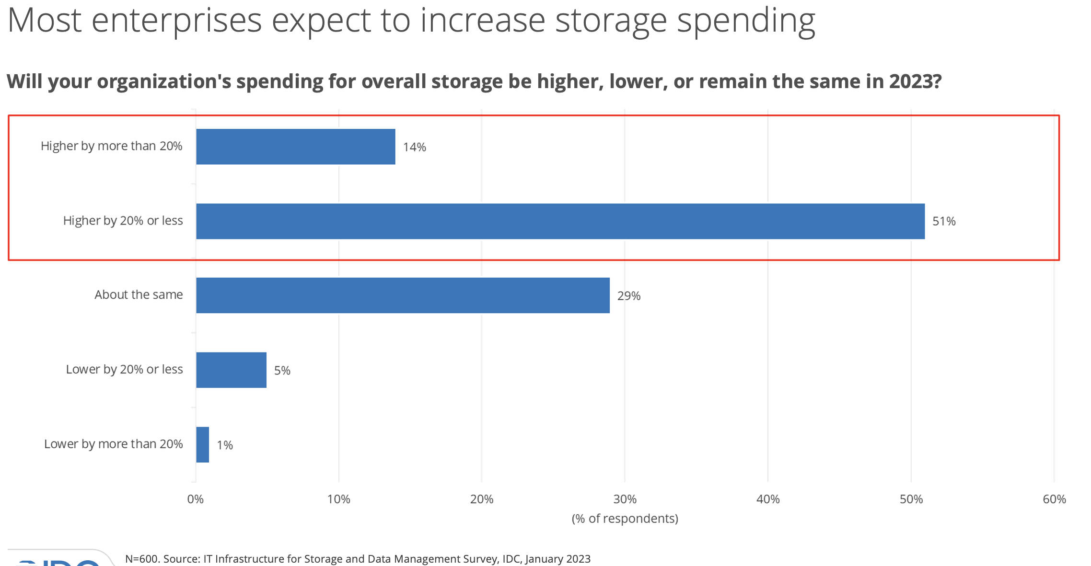

#### Fig. 5.1: Enterprise spending predictions in 2023

Primary drivers for Storage budget increases were due to the need for data protection fueled by massive data growth and customers looking for higher performance storage ©.

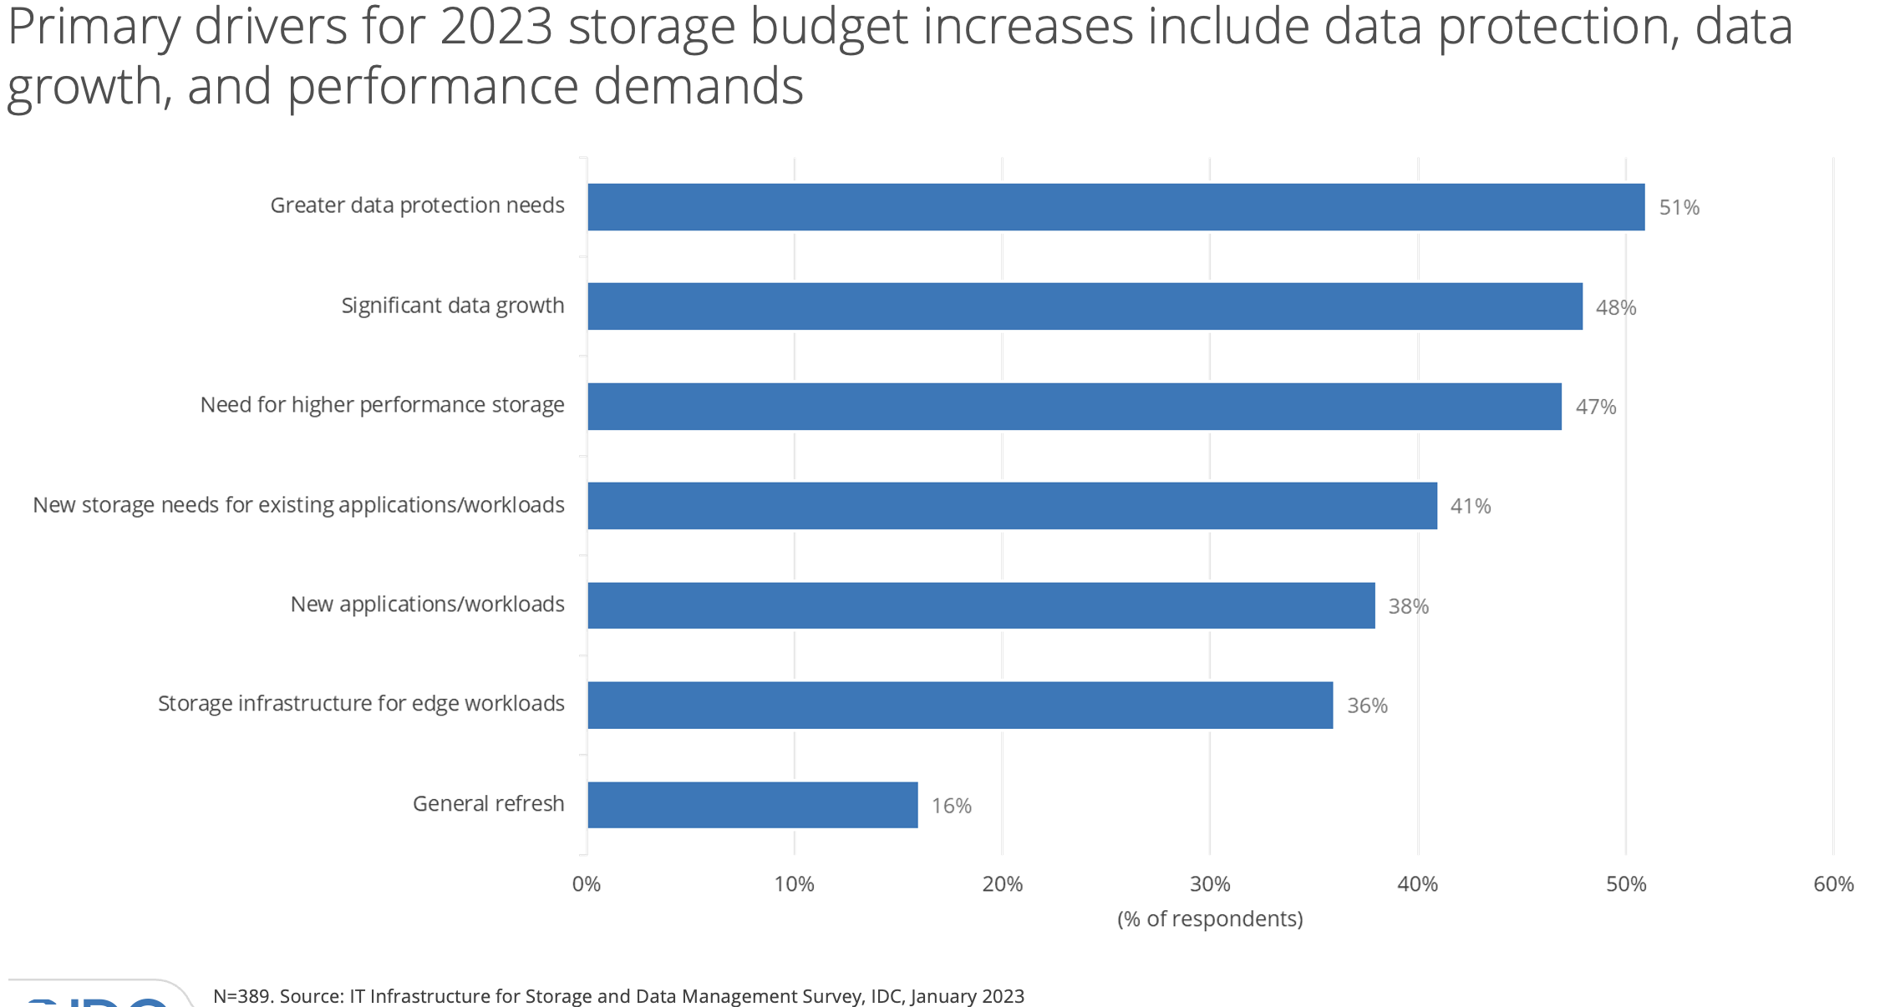

#### Fig. 5.2: Primary Storage Spending drivers

Aligned with these spend drivers, the largest expected storage spend was in data protection software (including container data protection), infrastructure as a service management and hyperconverged infrastructure HCI as seen in fig 5.3. below.

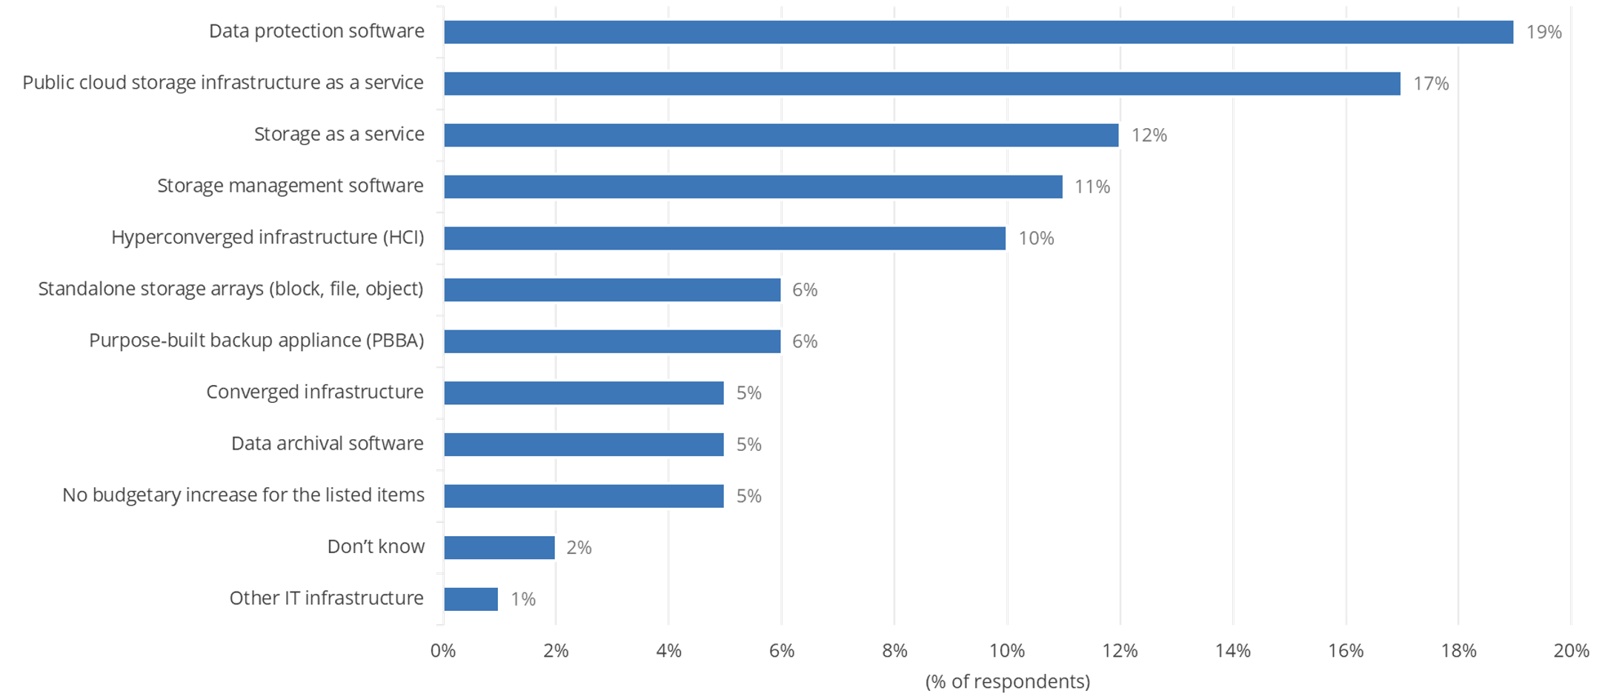

#### Fig. 5.3: Spending on key Storage solutions

A separate IDC ® survey “*IT Infrastructure for Storage and Data Management Survey*”, conducted in January 2023 also explored the primary customer use case requirements for Storage. See fig 5.4 below.



*N=389. Source: IT Infrastructure for Storage and Data Management Survey, IDC, January 2023*

#### Fig. 5.4: Storage Use cases, ranked in order of customer importance.

Again, Data Analytics, Data Backup and Recovery, Data Archiving and Virtualization/Server Infrastructure show up as key use cases for customer focus ©.

# Primary Storage Vendors’ Partner Program & Ecosystems

Having explored the Storage ecosystem technology categories, key vendors, top products, and customer storage spending data - the paper will now explore each of the top 8 Storage Hardware vendors’ Partner Ecosystem Programs.

Each Program is a substantial white paper of its own, but for the purpose of this paper, this chapter does a summary overview of each partner program and compares the vendor’s ecosystems based on number of partners, participating partner types, the storage technology categories represented, partnership program tiers and related partnership benefits.

As has been practiced throughout this paper, the information published is from publicly available sources only. When a Storage Vendor’s Partner program information is made available to only authenticated users, and sitting behind their web firewall, there is less information documented.

## 6.1 Dell Partner Program ®

Dell Technologies Partner Program comprises of the Dell APEX partner offerings, the Dell® Technology Alliances and Dell’s [Worldwide Channels Programs](https://static.ziftsolutions.com/files/8a9983aa7b712b24017b7481c1610f18/Canalys_vendor_channel_strategy_in_focus_Dell_Technologies_Aug2021.pdf).

With one of the broadest technology portfolios in the IT industry, spanning client, infrastructure (including Storage), cybersecurity, cloud and software, Dell’s market reach, and relevance in the IT ecosystem truly massive. Equally, for many channel and business partners around the world, Dell® is their biggest vendor - and Dell proudly boasts the largest GTM and channel storage ecosystem in the world.

The Dell Technologies Partner Program ® was re-launched in February of 2023, to cover both technology partners, services partners, and channel partners.

Partners delivered approximately [50% of Dell’s overall net revenue in 2022](https://www.dell.com/en-us/blog/new-year-consistent-partner-promise/) © and is growing rapidly. Dell ®’s Go-to-market approaches differ by business unit - for example, you will see in fig 6.1 below, that Dell has shifted over two thirds of its infrastructure business (servers, storage, networking) to an indirect model, reflecting the role of partners in building, delivering, and supporting complex infrastructure solutions.

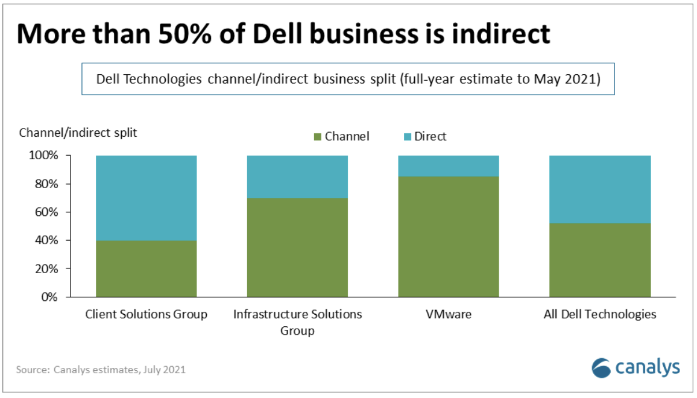

#### Fig. 6.1: Canalys ® Estimate, July 2021

The 2023 relaunch was aimed at further optimizing and driving an even larger percentage of revenue through Dell’s ® partners ©.

### 6.1.1 Dell ® Ecosystem Profile

Dell’s Partner Ecosystem ® currently shows 3,469 worldwide partners that are made up of the following partner types © (as described in the Dell partner ecosystem portal):

* Solution Providers (partners who resell products and services to the market, adding their unique services and technical capabilities)
* Distributors (partners who resell products to solution provider community, also providing information, quotes, technical support, after-sales services)
* Cloud Service Providers (partners who build cloud services platform/s to host Dell Technologies powered as-a-service offering for customers moving off premises)
* OEM Partners (partners who embed, attach, or integrate information management, protection & data security products to deliver full solutions)
* Systems Integrators (partners who manage deployment-to-operation lifecycle of complex IT solutions including consulting, design, installation, and support)
* Vertical Industry Partners / Federal Partners (partners who focus on delivering and implementing Dell products, solutions, and services into the federal space)

Dell Technologies Partner Program ® is structured with 5 partner tiers as described below:

* Authorized:
  + Base partner tier, providing base program rewards and benefits to registered partners based on their level of activity/engagement with Dell. Authorized partners also get to build relationships with Dell CSP partners.
* Gold:
  + Partners are eligible for online demo center services, and service delivery competency opportunities.
* Platinum:
  + These partners have access to invite-only Dell Technologies advisory boards, and other perks.
* Titanium:
  + Highest rebate potential and access to executive support
* Titanium Black:
  + Most exclusive tier available to only a handful of global strategic partners, and receive personalized service and support, early access to technology and roadmaps and expanded access to Dell executives.

Dell Technology Partners ® span multiple technology categories and capabilities. Dell’s primary Storage ecosystem categories of focus are listed as follows ©:

* Storage (APEX) Cloud Offers
* Data Storage (APEX) Services
* Converged and Hyper Converged Infrastructure (HCI)
* CSP Solutions
* Data Analytics & AI
* Data Protection
* Dell Endpoint Security
* Storage Networking
* Infrastructure & servers
* Database Workloads
* Storage Infrastructure

### 6.1.2 Dell® Technologies Extended Industry Partnerships

In addition to its partner program IT ecosystem, Dell Technologies [participates in several industry organizations](https://www.dell.com/en-us/lp/dt/industry-engagement) to collaborate with other leading vendors to define, evolve and share best practices to help shape the future of innovation in the IT industry. See Storage affiliated industry organizations below ©:

* [Information Technology Industry Council](https://www.itic.org/) **(ITI**®**)** – ITI is a trade association that represents companies from the information and communications technology (ICT) industry. As an advocacy organization, ITI works to influence policy issues aimed at encouraging innovation and promoting global competitiveness.
* [Institute of Electrical Engineers](https://www.ieee.org/) **(IEEE**®**)** – IEEE and its members inspire a global community to innovate for a better tomorrow through highly cited publications, conferences, technology standards, and professional and educational activities. IEEE is the trusted “voice” for engineering, computing, and technology information around the globe.
* [Storage Networking Industry Association](https://www.snia.org/) **(SNIA**®**)** – is a non-profit, global organization focused on developing and promoting architectures, standards and education programs to advance storage technology and to facilitate the efficient management, movement and security of information.
* [Trusted Computing Group](https://trustedcomputinggroup.org/) **(TCG**®**)** – Dell Technologies is a board member of TCG, a not-for-profit organization formed to develop and promote trusted computing technologies. TCG enables the benefits of trust in computing devices from mobile to embedded systems, as well as networks, storage, infrastructure, and cloud security. More than a billion devices include TCG technologies.

## 6.2 Huawei® Partner Program

Huawei’s Ecosystem information and collateral largely sits behind the firewall and is either region specific and/or not available for public consumption. The information included in the section below is therefore incomplete, but still provides enough of a summary that is useful for vendor comparison purposes.

Huawei’s partner program (named Huawei Partner Network) is a comprehensive one. It is made up of multiple separate programs, each onboarding different partner types, providing different benefits and requirements that align to various program tiers by partner type.

This richness of the ecosystem programs and offerings results in a level of complexity not seen in the other storage vendor programs that were studied.

Huawei Partner Network has 6 primary partner programs as indicated in fig. 6.2 below ©.



#### Fig. 6.2: Huawei Partner Network Program Onboarding site

A partner can join up to 13 separate sub-programs (as indicated by  below).

|  |  |  |  |  |
| --- | --- | --- | --- | --- |
| **Partner Type** | **Partner Program** | **Sub Program** | **Tiers** | **Benefits** |
| Sales Partner  now button stock vector. Illustration ... | Sales Partner Program | | Registered | Portal, Training, Deal Reg, Special Pricing, Product Promos, Channel Promos |
| Authorized | + Logo use, MDF, Demos |
| Silver | + Leads, Core Partner Support Rebates, Advisory Boards |
| Gold | + More MDF, More Rebate |
| VAP | + Direct Order, Credit line, Discounts, Financing, |
| Distributor | + MBO rebates |
| Consulting & Planning Partner now button stock vector. Illustration ... | No Access (behind firewall) | | | |
| Solution Partner | Ascend Program  now button stock vector. Illustration ... | | Member | Discounts, cloud voucher, Dev Zone, Remote Support. |
| Certified | + tech cert, events, training voucher, events, branding |
| Preferred | + joint dev., ecosystem mgr., strategy exchange |
| Huawei Enterprise Solution Program | Solution Component  Partners  now button stock vector. Illustration ... | Certified | Tech support, marketing support, leads, training |
| Preferred | + preferred tech support  forums, shared manager |
| Advanced | + preferred forums, dedicated mgr. |
| Solution Development Partner  now button stock vector. Illustration ... | Certified | Tech support, marketing support, leads, training |
| Preferred | + More dev fund, cloud vouchers, |
| Advanced | + More dev fund & mktg. fund, dedicated mgr. |
| Technology Certification Program  now button stock vector. Illustration ... | | Compatible | Interoperability testing for 3rd party compatibility |
| Validated | End-end verification of full joint solution |
| Enabled | Huawei enabled & differentiated solutions |
| Service Partners | ICT Service Partner Program  now button stock vector. Illustration ... | No Access (behind firewall) | | |
| Industry App Integration Service Partner Program now button stock vector. Illustration ... | No Access (behind firewall) | | |
| Authorized Service Center Service Partner Program now button stock vector. Illustration ... | No Access (behind firewall) | | |
| Business Operations Partner now button stock vector. Illustration ... | No Access (behind firewall) | | | |
| Talent Alliance Partner | ICT Academy now button stock vector. Illustration ... | | | Courses, Documentation, Competition, News |
| HALPS now button stock vector. Illustration ... | | | Unique Identity, Mktg. support, Training, Tech Support |
| IASCS now button stock vector. Illustration ... | | | No Access (behind firewall) |

### 6.2.1 Huawei® Ecosystem Profile

Huawei has an extensive partner ecosystem primarily made up of sales channel partners. Almost all of Huawei’s Storage sales are fulfilled by a channel partner. These channel partners are largely resellers & distributors concentrated in the Asia Pacific region as seen in fig 6.3 below.

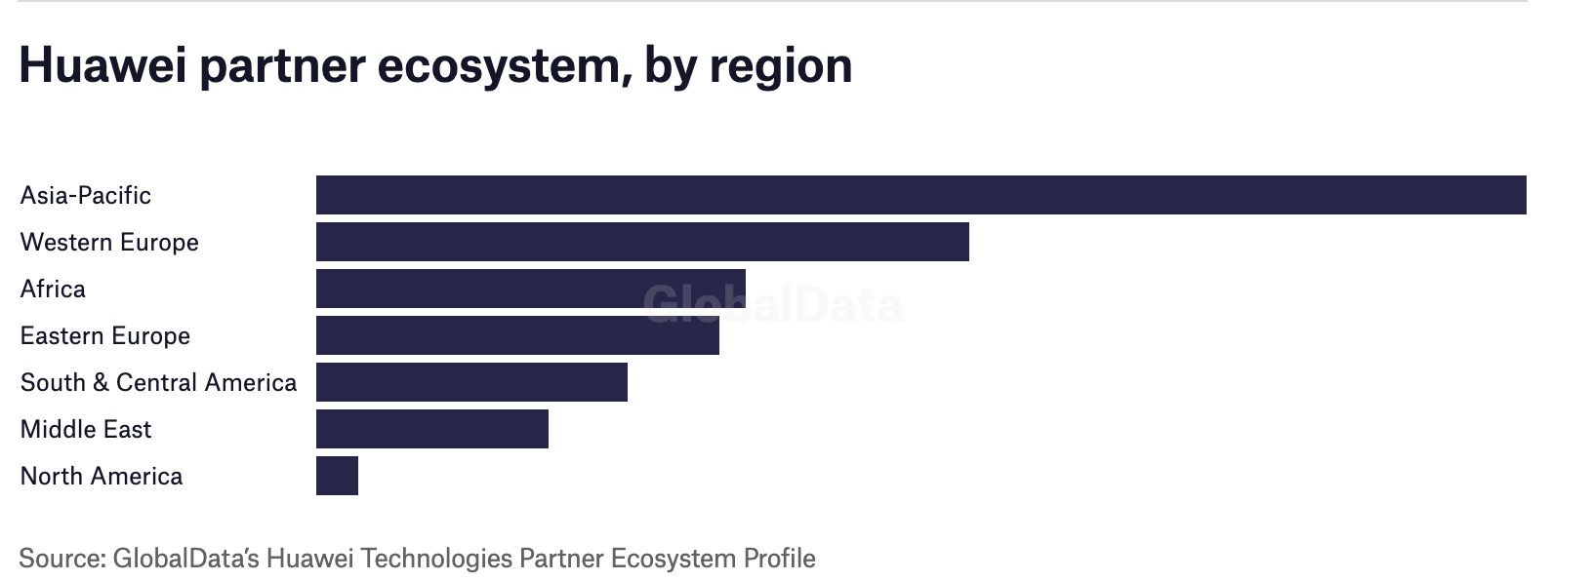

#### Fig. 6.3: Huawei partner distribution by region, Global Data

Huawei’s Channel Partner Tiers (as listed in the Partner Portal/Catalog) are based on Partner Types. Therefore, each partner type can qualify for different tiering as depicted below.

|  |  |  |  |  |
| --- | --- | --- | --- | --- |
| **Partner Track** | **Partner Types** | **Tiers** | | |
| Solution | ISVs, IHVs, SIs | Certified | Preferred | Advanced |
| Sales | Reseller, Distributor, VAR | Authorized | Silver | Gold |
| Service | Training Partners | 3 Star | 4 Star | 5 Star |

## 6.3 NetApp® Partner Program

The NetApp Partner Sphere Program was launched in April 2023, and is the evolution of its prior Unified Partner Program. It provides the programs, tools, and training help needed to accelerate storage ecosystem business. The launch simplified its ecosystem to go from a specialization-based approach to a competence-based approach. NetApp is pushing its partners to earn competencies in 3 areas: primarily Cloud Solutions, Hybrid Cloud and AI/Analytics.

Partner Sphere has multiple offerings and benefits for the NetApp’s ecosystem - namely, Learning Services (training), Deal transaction incentives and rewards, co-marketing and GTM branding (including joint collateral creation and event exposure), content syndication (for partner web content) and help with demand generation campaigns. NetApp’s partners receive programmatic benefits from when they onboard to the program, through their product integration, go-to-market, and sales journey.

### 6.3.1 NetApp® Ecosystem Profile

NetApp® maintains a Partner Catalog named Partner Connect to nurture and align its ecosystem of partners to NetApp’s technology.

Partner Connect currently lists 388 partners by the following categories:

* Technology Alliance (165 partners)
* Solution Provider (144 partners)
* Distributor (79 partners)

These partners are listed under the following ecosystem categories:

* AI
* Big Data
* Cloud & Data Services
* Infrastructure
* Converged Infrastructure
* Data Protection
* Security
* Storage Management
* StorageGRID
* Vertical Industries (Healthcare, Media and Video Surveillance)
* Virtualization

NetApp® offers 4 partner Tiers, based on a partner’s value and competencies. This is to help identify the right partners for the right customer opportunities. NetApp provides Benefits and Support to partners, will grow as a Partner ascends tiers.

* Approved:
  + Base program tier for registered partners providing access to an online partner hub and value-based sales incentives.
* Preferred:
  + Business training and enablement, access to marketing resources, MDF, and richer sales incentives
* Prestige:
  + Access to advanced workshops with NetApp specialists
* Prestige Plus:
  + Invitation only tier to NetApp’s most important global partners with special access to NetApp executives and more.

## 6.4 Hewlett-Packard Enterprise ® (HPE) Partner Program

HPE® Partner Ready provides the resources, tools, and training for partners to build, service and sell their products and services with HPE. The program is structured along 3 tracks - Build (solutioning, development, test, validation), Sell (on-premises and cloud) and Service (managed services, professional services) as illustrated in fig. 6.4 below.

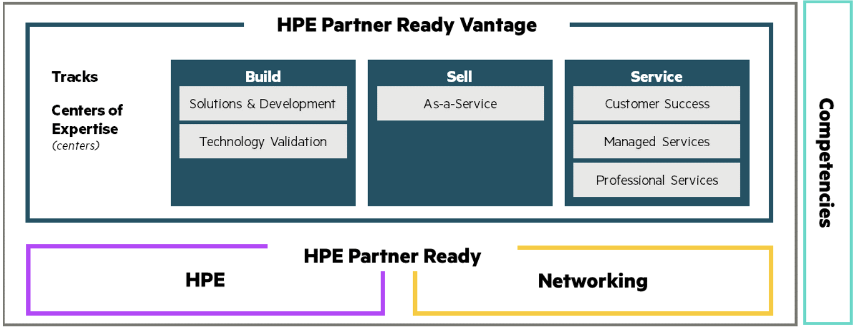

#### Fig. 6.4: HPE’s Partner Ready Program structure

The Build Partner track sits under HPE Partner Ready for [Technology Partner Program](https://www.hpe.com/us/en/alliance/technology.html).

Additionally, HPE® offers the Partner Ecosystem Catalog (Partner Connect) for its ecosystem partners to publish their offerings with HPE and generate awareness.

### 6.4.1 HPE Ecosystem Profile

HPE’s Partner Ecosystem is extensive, and its [Partner Connect catalog](https://partnerconnect.hpe.com/partners#content-top) © currently lists 47,971 partners across the 4 partner types below. (Some partners in the catalog have no partner types listed).

* [Technology Partner](https://techpartner.it.hpe.com/TechPartner/PartnerHome.xhtml) (1,353 partners):
  + ISVs and IHVs who integrate, test and market joint offerings with HPE)
* Solution Provider (30,034 partners)
  + Offers a broad range of technology, solutions, and services to customers with the skills and tools of HPE.
* Service Provider (976 partners):
  + MSPs, and CSPs who work with HPE to create Service-Provider ready solutions and engage in a joint GTM partnership.
* OEM Partner (34 partners):
  + Helps OEM partners showcase their innovations globally, using HPE’s technology and industry leading services (under the partner’s brand).

HPE’s Technology Partners are grouped by the specializations & tiers below:

* Networking partners (Switching, Wireless LAN)
* Infrastructure partners (Converged Systems, Hyper Converged Infrastructure (HCI)
* Server partners
* Storage partners (Storage Virtualization, Container Storage, Data Protection, Enterprise Application Storage, File and Object Storage, All Flash and Hybrid Storage)
* Vertical Industry partners

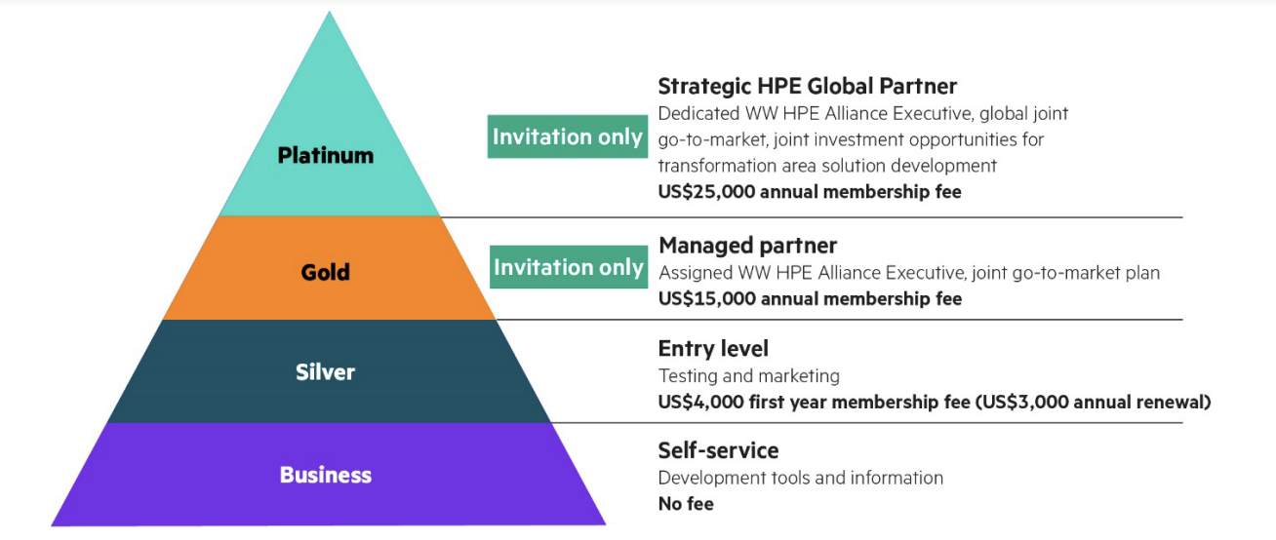

#### Fig. 6.5: HPE’s Technology Partner Tiering

HPE Ecosystem Technology Partner program benefits by tier, is in table below.

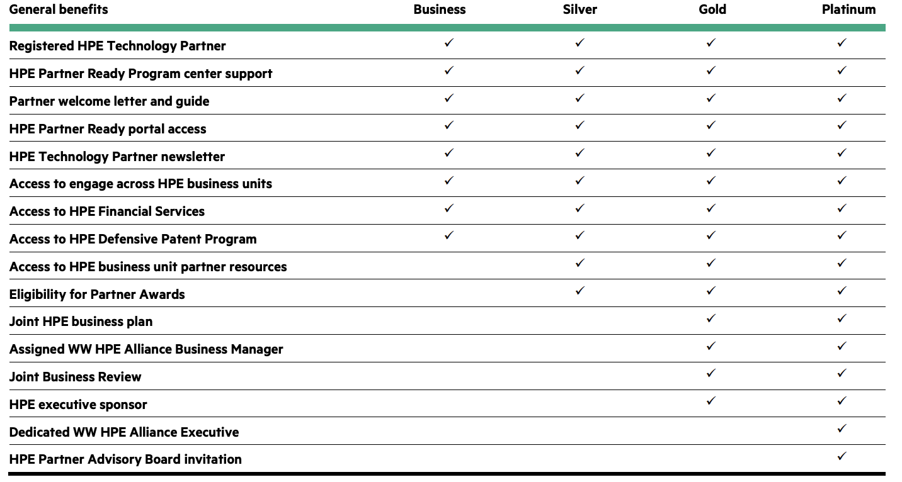

## 6.5 Pure Storage ® Partner Program

Pure® Partner Program is a simple to understand, well targeted and impactful ecosystem program, unifying all partner types under a single program umbrella. Pure Storage is 100% channel led since its founding and its partner program is therefore critical to its success. Its Technology Alliance Program (TAP) works with technology companies giving them access to Pure’s latest APIs & software development kits to align and test their products and solutions with Pure Storage hardware products. Partners can also access Pure hardware via an on-site demo lab.

The TAP Program has 3 tiers based on the technology partner’s level of partnering commitment:

* Foundation Tier:
  + The entry point for partners establishing a relationship with an intent to evolve into a stronger partnership with Pure.
* Advanced Tier:
  + Companies that have initiated a deeper level of engagement, close technical alignment, and go-to-market strategy.
* Strategic Tier:
  + Proven companies that have shown a high degree of commitment, innovation, technical alignment, business synergy, and value of a joint solution.

The Program benefits (including Technical and Marketing benefits) as listed in fig 6.6 below ©:

#### Fig. 6.5: Pure Storage Partner Program Benefits by Tier

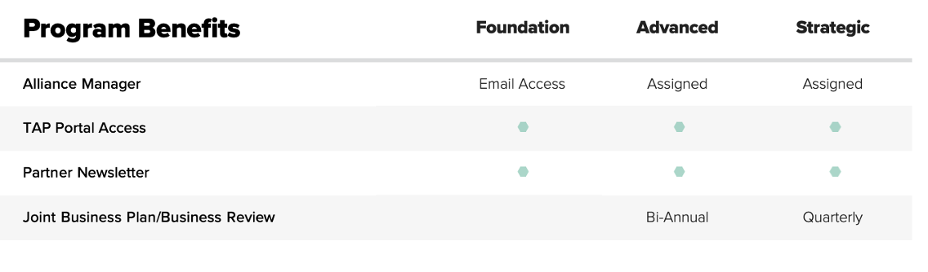

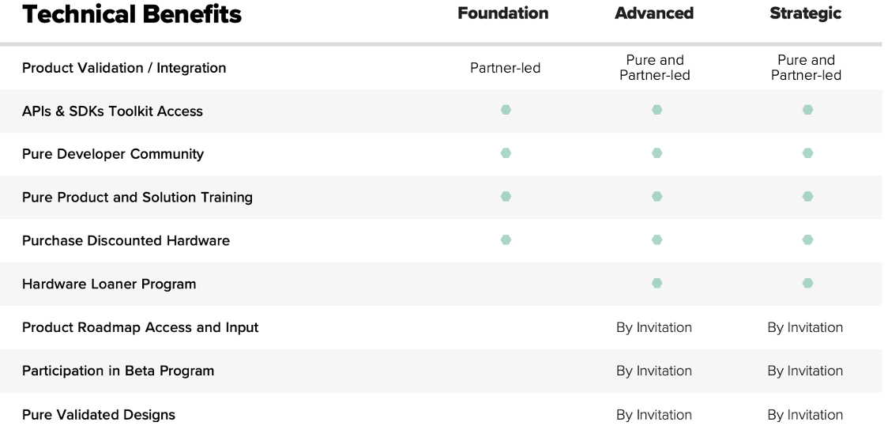

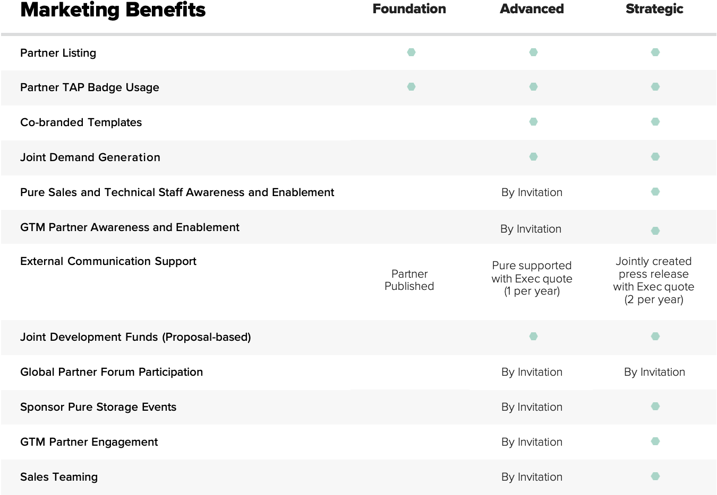

### 6.5.1 Pure Storage ® Ecosystem Profile

The Pure Partner Ecosystem is made up of 94 partners of the following partner types:

* Technology Alliance (49 partners)
* Global Systems Integrators (5 partners)
* Managed Service Providers (14 partners)
* Resellers (32 partners)

In keeping with Pure Storage’s program simplicity, its Reseller program only has two tiers:

* Preferred:
  + Pure’s base program for registered and engaged active partners
* Elite:
  + High tier program offering additional incentives, discounts, marketing resources, and more.

Pure Storage ecosystem partners are further segmented into the following technology categories:

* Analytics & AI
* Cloud
* Data Protection
* Security and governance
* Enterprise Applications
* Hybrid Cloud
* Intelligence & Information Management
* Infrastructure
* Vertical Industries (e.g.: healthcare)

## 6.6 Hitachi® Partner Program

The Hitachi Vantara Partner Program is structured so partners can build (create), sell (resell, deliver) and service (manage) ecosystem solutions per customer requirements. Since traditional partner boundaries are blurring, many partners will participate in multiple partner models as seen below in fig 6.6.

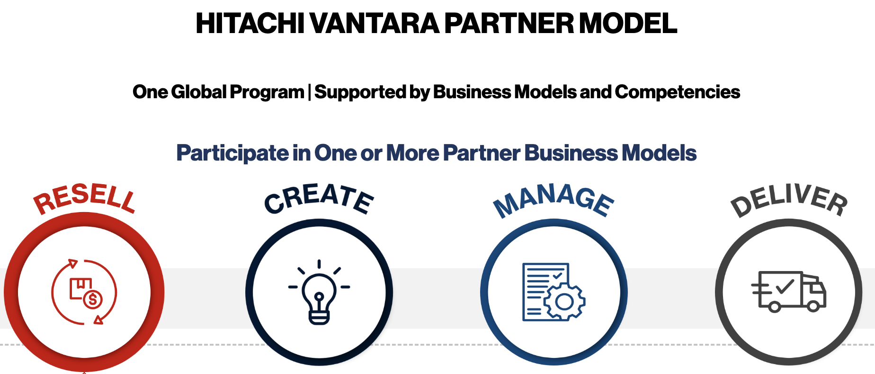

#### Fig. 6.6: Hitachi Vantara Partner Model

The program offers multiple partnership benefits aligned to each of the partner models as summarized below:

* Resell Partner Benefits:
  + Deal registration discounts and Market Development Funds (MDF), rebates and incentives, Demo Program, online training, and competency learning paths.
* Create Partner Benefits:
  + Solution definition workshops, Lab access for integration, test, and certification support, access to Hitachi Developer Network, GitHub and Demo center.
* Manage Partner Benefits:
  + Flexible financial models, joint strategy and service development workshops, joint go-to-market (GTM).
* Delivery Partner Benefits:
  + Frontline delivery support and tools, professional service, co-sell opportunities, training delivery kits and service catalog.

### 6.6.1 Hitachi® Ecosystem Profile

Hitachi® Vantara’s [Partner Locator](https://www.hitachivantara.com/en-us/partners/partner-locator.html) shows many resales and channel partners grouped by country.

There are 42 primaries partners identified by business model and classified by the partner types listed below.

* Technology alliances and ISVs (12 partners)
* Global Systems Integrators (9 partners)
* Cloud and Managed Services (11 partners)
* Service Delivery (10 partners)
* Resell Partners (100’s by country)

These partners are further categorized by 3 primary competencies:

* Edge-to-Core-to-Cloud Infrastructure
* Intelligent Data Operations
* Data-Driven Solutions

Unique to Hitachi®, its partner ecosystem program doesn’t provide tiered benefits to partners. Partners are instead aligned to the business models, competencies, skills, vertical specialization, and sales revenue.

## 6.7 IBM® Partner Program

IBM Partner Plus is a new Ecosystem program launched by IBM in January 2023 to optimize how it works with its partners giving them unprecedented access to IBM resources, incentives, and support to deepen their technical expertise and help speed up time to market. It provides 3 distinct tracks for Build, Sell and Service Partners, with the partner journey as illustrated in IBM’s program website (captured in fig. 6.7 below).

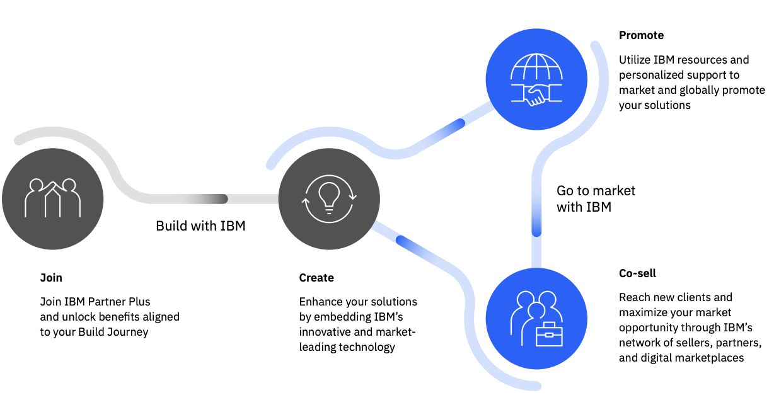

#### Fig. 6.7: IBM Partner Journey.

Partner program benefits are aligned to the 3 partner tracks and summarized in the table below.

|  |  |  |  |
| --- | --- | --- | --- |
|  | **Incentives** | **Access** | **Support** |
| Build | Free WatsonX credits | Build Lab for integration & validation | Technical Experts |
| Sell | Publish & transact in IBM Marketplace | Sales, technical & marketing resources | Demand Generation Campaigns, Co-Sell |
| Service | Training credits | Dedicated local services resources | Services co creation support |

### 6.7.1 IBM® Ecosystem Profile

IBM® has a very extensive partner network with 38,810 partners identified in their Partner Plus [Directory](https://www.ibm.com/partnerplus/directory/companies?p=1), some active and perhaps many inactive. They are made up of the following partner types:

* VAR/Reseller/Solution Provider (1081 partners)
* Global and Regional Systems Integrators (657)
* Managed Service Providers (477)
* Independent Software Vendors (339)
* Managed Security Service Providers (270)
* Distributor (59)

Partner Plus has their top partners qualified into the following 3 tiers:

* Silver (612 partners)
* Gold (404 partners)
* Platinum (193 partners)

Partner Plus Ecosystem vendors are grouped into the following Storage technology categories:

* Cloud
* AI/ML
* Data Analytics
* IT infrastructure
* Data Security
* Vertical Industry
* Data Storage

## 6.8 Lenovo ® Partner Program

Lenovo® prides itself as a partner-first company with 95% of its sales going through its Partner Channe ©l. Their Partner program is called Partner Engage and works with a wide array of industry ecosystem partners to align technology and provide integrated solutions to customers. In July 2023, Lenovo launched the Lenovo Partner Hub, an integrated portal providing a single access point to tools, resources, and intelligent, personalized information, enabling channel partners to grow their businesses.

The Partner Engage Program groups partners into the 4 tiers below, with partnership benefits aligned to each tier as seen in fig 6.8 that follows.

* Authorized
* Silver
* Gold
* Platinum

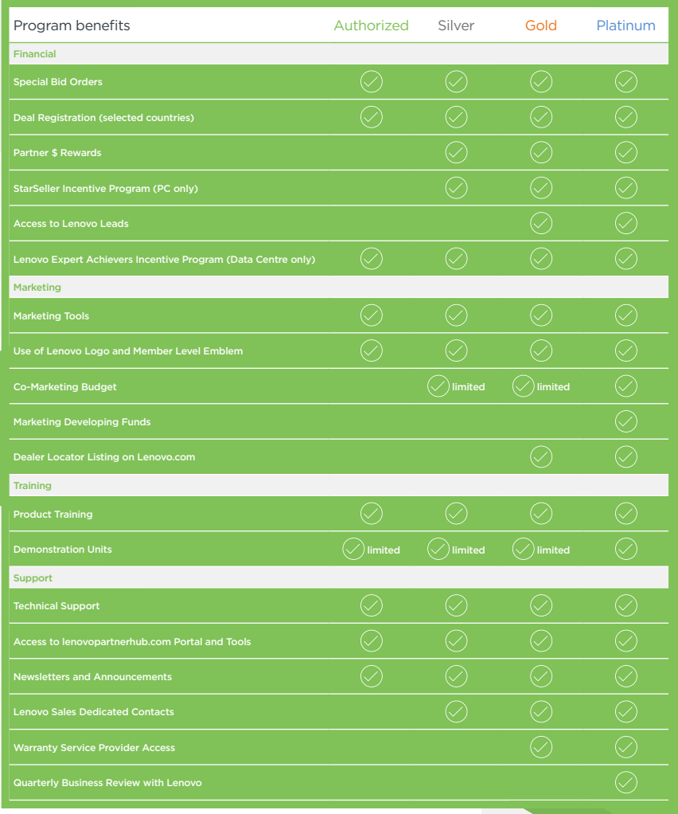

#### Fig. 6.8: Lenovo Partner Benefits by Tier.

### 6.8.1 Lenovo ® Ecosystem Profile

Lenovo’s ® Partner Ecosystem lists 183 key partners (81 technology partners and 101 channel partners) as per [Partnerbase](https://www.partnerbase.com/lenovo) ®. Top ecosystem names VMware ®, Veeam, Red Hat ®, Citrix ®, SUSE ®, Oracle ®, SAP ®, Pivot3 ®, Kyndryl ®, Nutanix ® and Microsoft ® are listed as strategic software alliances in Lenovo’s website.

Access to additional partner information is limited.

# Storage Vendor Ecosystem Comparison & Learnings

The 5 key observations from the prior chapter’s Storage Vendor Ecosystem comparisons are as follows:

* IT Ecosystems and Partner programs are **dynamic** and continually evolving. Most Storage Hardware Vendor Ecosystem programs have either been relaunched, renamed or significant new feature/benefits added over the last 24 months.
* IT Ecosystems are **continually expanding** with new partners joining weekly. As customer demands increase, more vendors are expanding their solution offerings by forming new partnerships that provide more than ever before. These vendors aren’t only targeting big named Technology Partners (in each of the tech layer categories), but also onboarding smaller niche players with critical emerging technology that will be the next 800-pound gorilla a year or two from now.
* IT Ecosystem programs are urgently being **simplified**. Under the veil of Ecosystem Modernization, many programs have Unified their partner programs where ALL partner types are onboarded through a single “front door”, regardless of them being a “build”, “sell” or “service” partner. The Ecosystem programs then let partner dip into benefits and capability in each of the 3 tracks as needed.

This makes sense, since Partner types are blurring and most partners overlap between tracks (i.e.: many traditional build-partners, also service and sell to customers and vice-versa). Programs are also reducing the number or partnering tiers (and unifying benefits aligned to tiering) to maintain program richness but reduce complexity.

* Not all Technology layers and vendors are equally critical for Storage vendors. Storage Software (layer) Vendors for example are essential to Storage Hardware vendors - with each highlighting the other for GTM awareness in their respective Ecosystem catalogs (e.g.: Backup and Recovery vendors each publish their relationships with the Storage Hardware Vendors). But technology vendors further up the architectural stack/layers (e.g.: Business and User layer technology vendors) just see Storage as “infrastructure” that they automatically run on and therefore don’t have Storage vendors called out or publicized in their ecosystem.
* Channel Partners are the primary route-to-market for Storage Hardware Vendors with a large majority of the company’s revenue generated through these business partners (verses direct selling). While most of these vendors also have digital marketplaces, Storage is still primarily bought and sold through channel partners.

## 7.1 Ecosystem Partner Targeting

The most successful IT Ecosystems comprise of partners and products that are defined by the following characteristics.

Partners/products that have:

* Key features and capability that solves customer problems or provides new benefits.
* Strategic market relevance and is widely used by customers (e.g.: Vendor market share)
* Operate in an area of High Growth (e.g.: High forecasted customer-spend category)
* Open technology, with big client/partner ecosystems of their own (for multiplier-effect)
* Utilization and applicability across multiple industries and verticals
* Strong motivation to work with hardware vendor and has a simple engagement process
* Coverage and support across multiple regions and geographies

## 7.2 Best Practice: Pure Storage ® IT Ecosystem

Per the criteria listed above, Pure Storage’s IT ecosystem is worth highlighting as a best practice. Their ecosystem is small, targeted, covers all technology categories with strong market leading partnerships. They are 100% channel-led and their Pure Storage® Partner Program is simple, comprehensive, and is easy to understand and navigate.

The fig. 7.1 below is an illustration of the Pure Storage Ecosystem technology partnerships characterized by technology layer.



#### Fig. 7.1: Illustration of Pure Storage’s Partner Ecosystem.

# Conclusion & Recommendations

A Storage IT Ecosystem is an inter-dependent relationship between the Storage vendor, its technology partners, services partners, channel partners and the ultimate end customer.

Today’s IT customer maintains an average of 7 vendor relationships - illustrating the importance of a well-integrated and diverse ecosystem to satisfy customer needs. The best ecosystems find equilibrium when each participant is benefiting and winning, which in turn makes the IT ecosystem expand and grow rapidly.

An IT ecosystem should be both rich, yet simple inclusive of complementary partnerships to create both technical and business synergy.

Having reviewed analyst research, market forecasts, industry data, customer polling data, field escalation reports, user consumption preferences; and reviewed technology, services & channel company websites - what follows is a recommendation for an IT ecosystem based on both market and customer-centric analysis.

This paper recommends a Storage IT Ecosystem prioritized on the 4 solution areas and target ecosystem partners listed in the table below.

|  |  |  |
| --- | --- | --- |
|  | **Storage Ecosystem Solution** | **Targeted Ecosystem Partners** |
| 1 | Data Protection Software or appliance (including backup and recovery, disaster recovery, data security and data archiving software) | Veritas ®, Commvault ®, Veeam ®, Rubrik ®, Trilio ®, Cohesity ®, Acronis ®, Arc Serve ®, Mimecast ®, Microfocus ® |
| 2 | Container Platforms requiring Persistent Storage | Red Hat/OpenShift ®, SUSE/Rancher ®, Mirantis ®, Alibaba ®, VMware/Tanzu ®, Digital Ocean ®, Portworx ®, Canonical ® |
| 3 | High Performance Storage systems (including Hyperconverged Infrastructure) | VMware ®, Nutanix ®, StarWind ®, Scale Computing ®, Cisco ®, Quantum/Pivot3 ®, Stratoscale/Symphony ® |
| 4 | Storage Management & BI/Analytics software | SAP ®, Salesforce/Tableau ®, Microfocus ®, Confluent ®, Tibco ®, Qlik ® , Alteryx ®, MicroStrategy ®, SAS ® |
| 5 | Storage as a Service and Infrastructure as a Service (IaaS) solutions | AWS ®, Google GCP ®, Azure ®, IBM Cloud Storage ®, Digital Ocean ®, HPE GreenLake ®, Dell ECS ®, NetApp Cloud Volumes Service ® |

While bigger named Ecosystem vendors are desired for each solution area, it is important find equilibrium (per section 7.1 above) and recruit partners who have the key technology capability but also with the drive and motivation to work with you (to delivering customer value) today and can be the next big player soon.

The short term-strategy is to increase customers/revenue by leveraging market share by partnering with an ecosystem partner who has lots of customers, but the real win is to identify innovative new players who can help “grow the storage industry pie” for all. Therefor the recommendation is to have a healthy mix of well-known, and lesser-known but promising niche players, to create a balanced and future-proofed ecosystem.

Having the Technology IT ecosystem in place is only part of the overall solution. Co-created product and services need to also reach customers. Complementing the technology partner ecosystem with a strong business channel network globally, is as critical to get solutions to customers and generate revenue growth for all.

Customers are country and region specific and channel partners operate where the customers are. Therefore, a sound Channel ecosystem is bottoms up driven and varies by city, country, and region.

Optimizing channel reach is a big topic and will be explored via a separate white paper in the future.

# References

|  |  |
| --- | --- |
| [1] | <https://www.forbes.com/sites/forbestechcouncil/2022/02/25/importance-of-an-ecosystem-to-deliver-it-solutions-that-enable-todays-digital-world/?sh=221153e125c5> |
| [2] | <https://www.canalys.com/insights/Have-the-industry-s-channel-chiefs-really-moved-to-an-ecosystem-model>  [3] 2023 Trends and Priorities : Enterprise Storage Infrastructure, IDC Survey  [4] IDC’s Worldwide Enterprise Infrastructure for Workloads Market Forecast, 2023-2027  [5] [Application Container Market Size 2023, Forecast By 2032 (reportsanddata.com)](https://www.reportsanddata.com/report-detail/application-container-market)  [6] [Sky Quest Container Report](https://nam11.safelinks.protection.outlook.com/?url=https%3A%2F%2Fwww.skyquestt.com%2Freport%2Fkubernetes-market%23%3A~%3Atext%3DKubernetes%2520Market%2520size%2520was%2520valued%2Copen%2520source%2520software%2520after%2520Linux&data=05%7C02%7CTariq.Nazeer%40futurewei.com%7C2bf9ecbd0cf84df2320708dc1cfb5c8a%7C0fee8ff2a3b240189c753a1d5591fedc%7C1%7C0%7C638417113142621704%7CUnknown%7CTWFpbGZsb3d8eyJWIjoiMC4wLjAwMDAiLCJQIjoiV2luMzIiLCJBTiI6Ik1haWwiLCJXVCI6Mn0%3D%7C0%7C%7C%7C&sdata=ZXxb6U6bUd%2Bq%2FFhqLtHGe7K4VTSlKdScRcTo4sORl2E%3D&reserved=0)  [7] G2 Scoring for each category?  [8] IT Infrastructure for Storage and Data Management Survey, IDC, January 2023  [9] <https://www.dell.com/en-us/blog/2023-dell-technologies-partner-program-powered-by-collaboration/>  [10] [HPE Technology Partner Program | HPE](https://www.hpe.com/us/en/alliance/technology.html)  [11] <https://www.netapp.com/newsroom/press-releases/news-rel-20221018-256984/>  [12] <https://www.channelasia.tech/article/702512/netapp-launches-new-partner-sphere-program/>  [13] <https://www.channelfutures.com/channel-business/brand-new-netapp-partner-program-represents-foundation-of-the-future->  [14] <https://www.hpe.com/us/en/solutions/partners.html>  [15] <https://www.hpe.com/us/en/alliance/technology.html>  [16] <https://www.hpe.com/psnow/doc/4aa6-5669enw.pdf?jumpid=in_pdfviewer-psnow>  [17] <https://techpartner.it.hpe.com/TechPartner/PartnerHome.xhtml>  [18] <https://www.hpe.com/psnow/doc/a00124698enw.pdf?jumpid=in_pdfviewer-psnow>  [19] <https://partnerconnect.hpe.com/partners#content-top>  [20] <https://partner.huawei.com/#/en/web/worldwide>  [21] <https://www.verdict.co.uk/huawei-technologies-partner-ecosystem-profile/?cf-view>  [22] <https://www.prnewswire.com/news-releases/pure-storage-modernizes-partner-program-to-align-with-as-a-service-evolution-301461619.html>  [23] <https://www.scientific-computing.com/news/pure-storage-announces-technology-alliance-partner-program>  [24] <https://www.purestorage.com/content/dam/purestorage/pdf/datasheets/ds-pur02720-tap-program.pdf>  [25] <https://www.hitachivantara.com/en-us/partners/become-partner.html>  [26] <https://www.ibm.com/partnerplus>  [27] <https://www.ibm.com/partnerplus/directory/companies>  [28] <https://newsroom.ibm.com/2023-01-04-IBM-Launches-New-Way-to-Partner-through-IBM-Partner-Plus>  [29] <https://news.lenovo.com/pressroom/press-releases/lenovo-launching-new-global-partner-hub-providing-personalized-real-time-sales-tool-transformation/>  [30] <https://www.partnerbase.com/lenovo>  [31] <https://www.crn.com/partner-program-guide/ppg2023>  [32] … |